# CS 255 System Design Document Template

## UML Diagrams

### UML Use Case Diagram

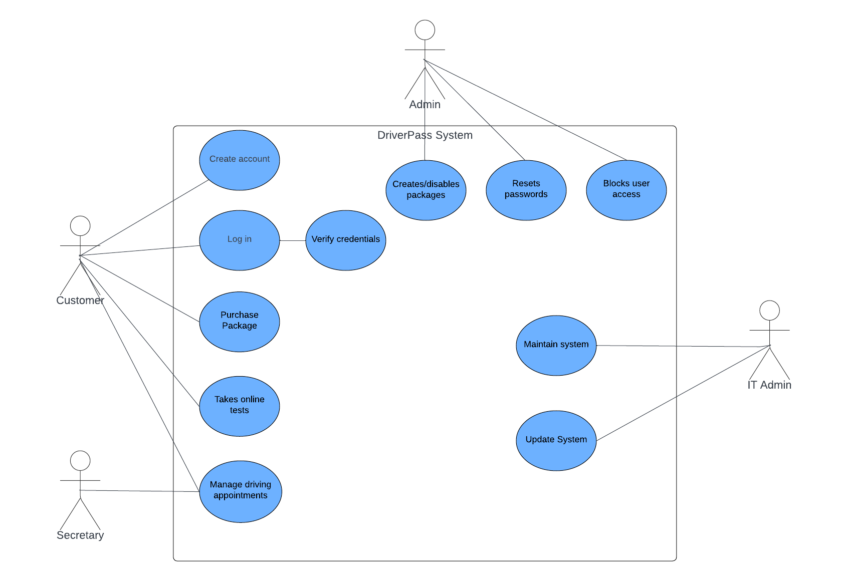

### UML Activity Diagrams

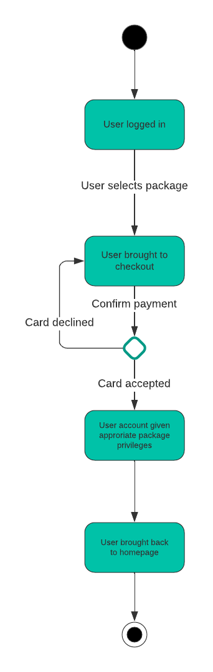 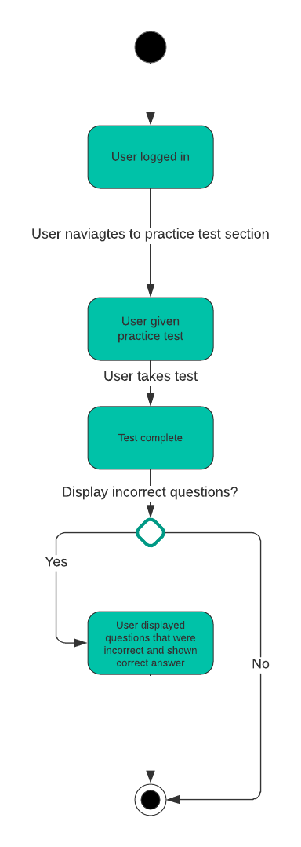

### UML Sequence Diagram

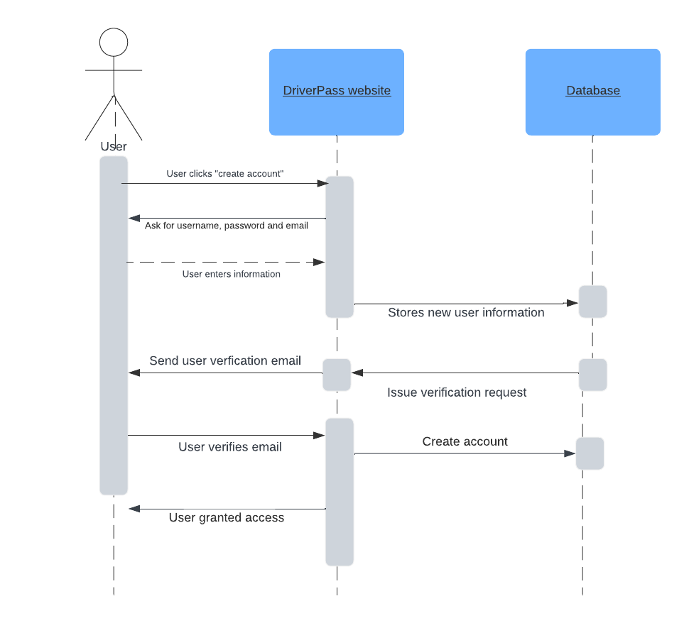

### UML Class Diagram

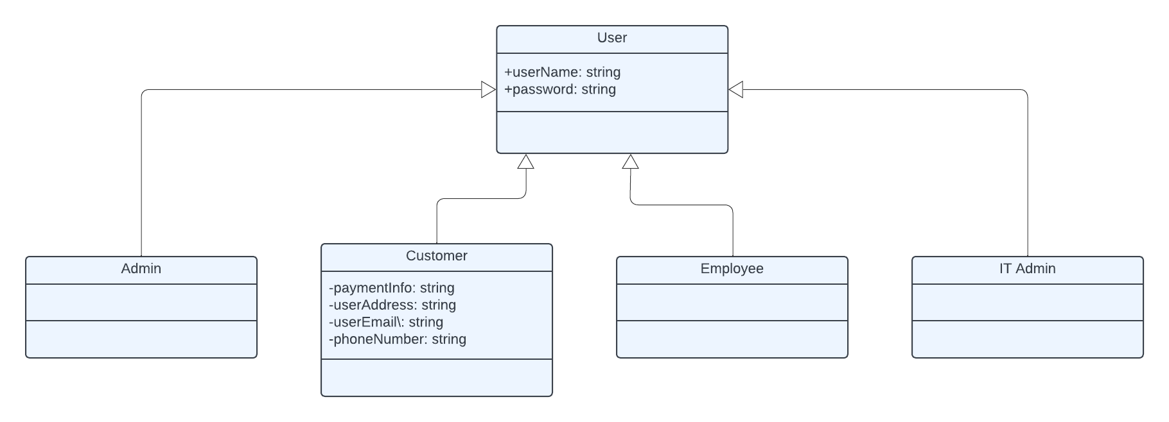

## Technical Requirements

There are a couple of technical requirements for this system. This website needs to be able to function on both computers and mobile devices. The client has requested it be a Cloud-based program and offline access is expected as well. There must also be a verification system put into place to determine the level of access that each user should have based on the type of user they are. This way customers do not have admin privlieges, administrators having total access, etc.